Day 40 – OR Gate Using MUX

Introduction: Implemented an OR Gate using Multiplexers (MUX).
The OR gate gives a HIGH output when at least one input is HIGH.
Boolean Expression:
Y = A + B
The OR gate was implemented using:
- 2:1 MUX
- 4:1 MUX

1. OR Gate Using 2:1 MUX

Design
For the 2:1 MUX:
- I0 = A
- I1 = 1
- S = B
The MUX selects the required input based on the select signal.
Therefore:
Y = A + B

Design Code:

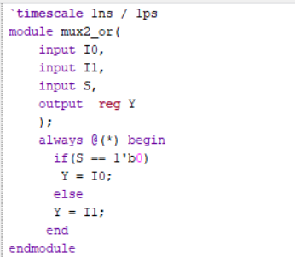

Testbench:

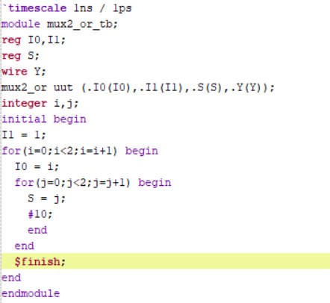

Waveform:The waveform verifies the correct OR gate operation.

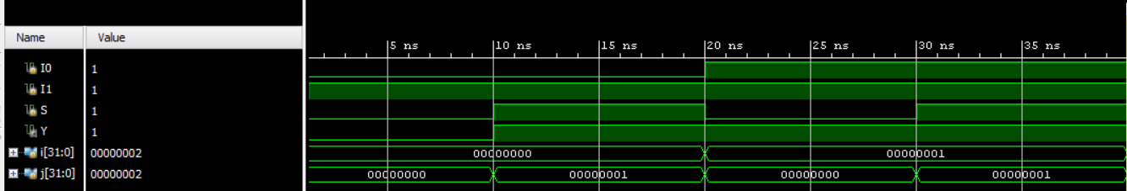

Schematic: The schematic shows the connections used to implement the OR gate using a 2:1 MUX.

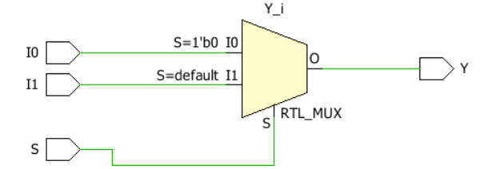

2. OR Gate Using 4:1 MUX

Design
For the 4:1 MUX:
- I0 = 0
- I1 = 1
- I2 = 1
- I3 = 1
- S1 = A
- S0 = B
The MUX selects the required input according to the select lines.
Therefore:
Y = A + B

Design Code:

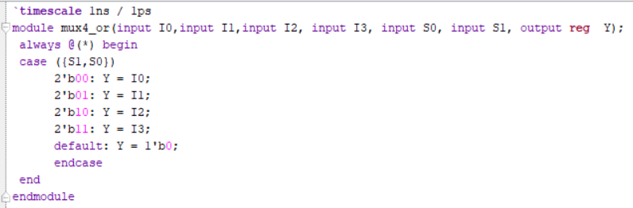

Testbench:The testbench uses a for loop to check all the select combinations.

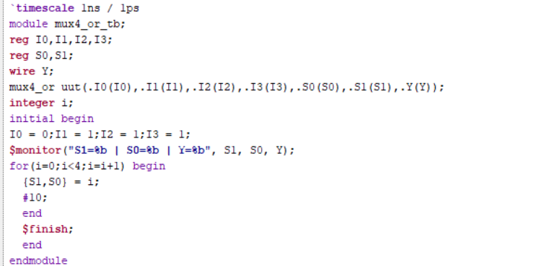

Waveform:The waveform verifies the correct OR gate operation.

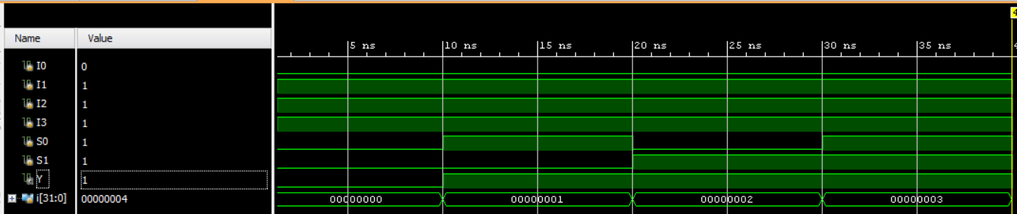

Schematic:.The schematic shows the connections used to implement the OR gate using a 4:1 MUX.

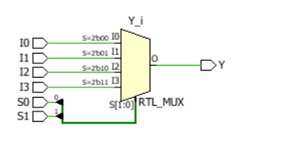

Observation
- The OR gate was successfully implemented using 2:1 and 4:1 MUXes.
- The output follows the required OR gate operation.
- The waveform verifies the expected output.
- The 2:1 and 4:1 MUX implementations produce the same OR gate functionality.

#PHANEENDRA.SINGUDASU

